UI Issues fixed

Two of these issues did not replicated in my environment using the IE as the indicated browser. They will have a note in red **“Working OK”**

=====================================================================================

The same issue in tracking bar as current UI. Text cut off when using other languages:

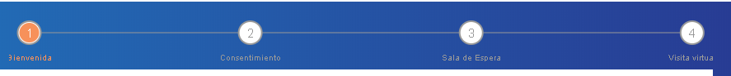

**“Working OK”**

=====================================================================================

Also cut off in English. The last letter of see doctor. Screen shot is from chrome.

**“Was Fixed”**

=====================================================================================

The button with light gray color may be all right. I checked design screen shot . it is the same.

button without color:rgba(255, 255, 255, 0.00); font-size: 12pt; font-family: "Times New Roman",

**This has a hover effect, initially will be light gray then on hover will change to orange**

=====================================================================================

Wating room second view:

**“Was Fixed”**

=====================================================================================

In IE:

**“Working OK” – In IE**

=====================================================================================

IE consent view:

**“Was Fixed”**